Figure One:

Caption: dog with wheelchair (PublicDomainPictures.net)

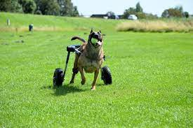

Also see https://www.youtube.com/watch?v=GwFvb5ly7sY

