Illustrations with Captions
(illustrations herein are draft-quality, to use for reference; higher-quality images to come via WeTransfer)

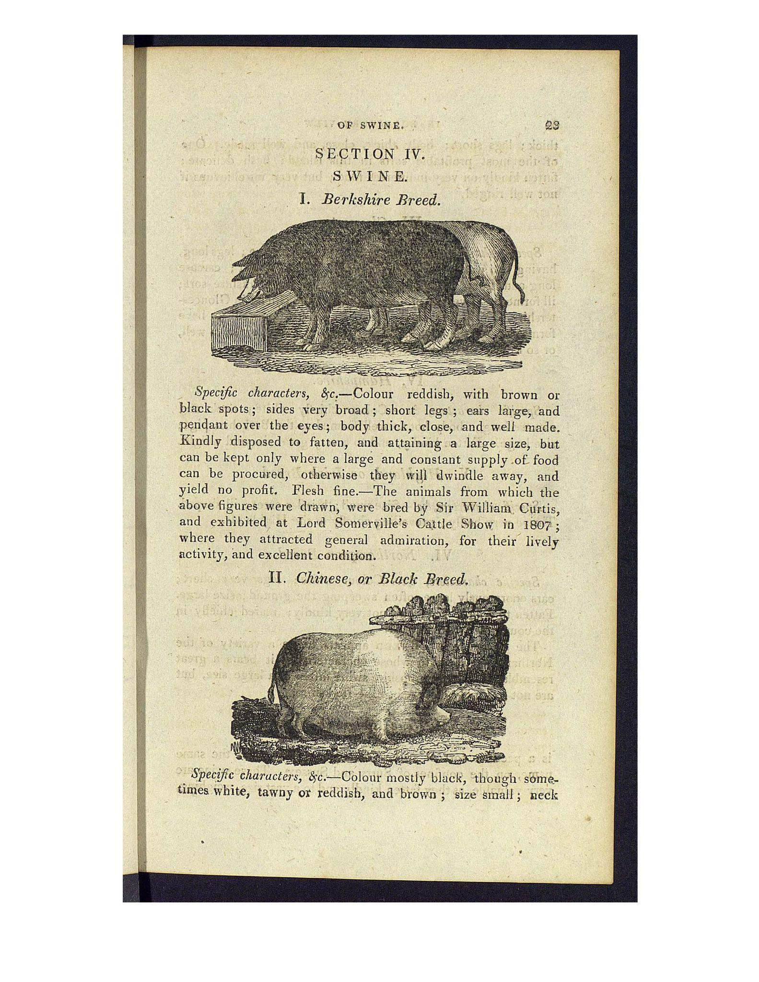

Fig. 1: ‘Berkshire Breed’ and ‘Chinese, or Black Breed,’ from Thomas Horne Hartwell, The complete grazier, or, Farmer's and cattle-breeder and dealer's assistant (London: Bradwell, Craddock and Joy, 1816), p. 23.

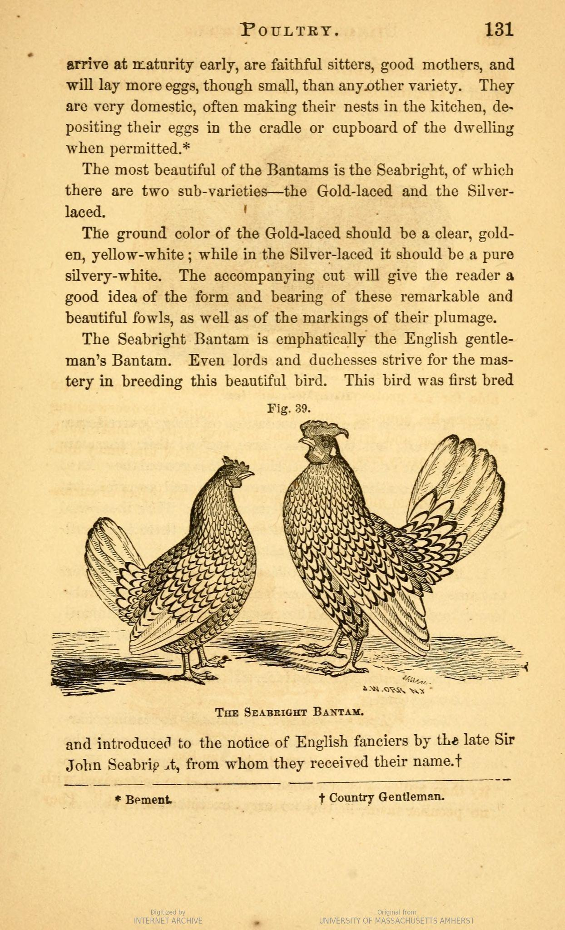

Fig. 2: ‘The Seabright Bantam,’ from D.H. Jacques, The barn-yard; a manual of cattle, horse and sheep husbandry (Rev. Ed. New York: G.E., 1866), p. 131.
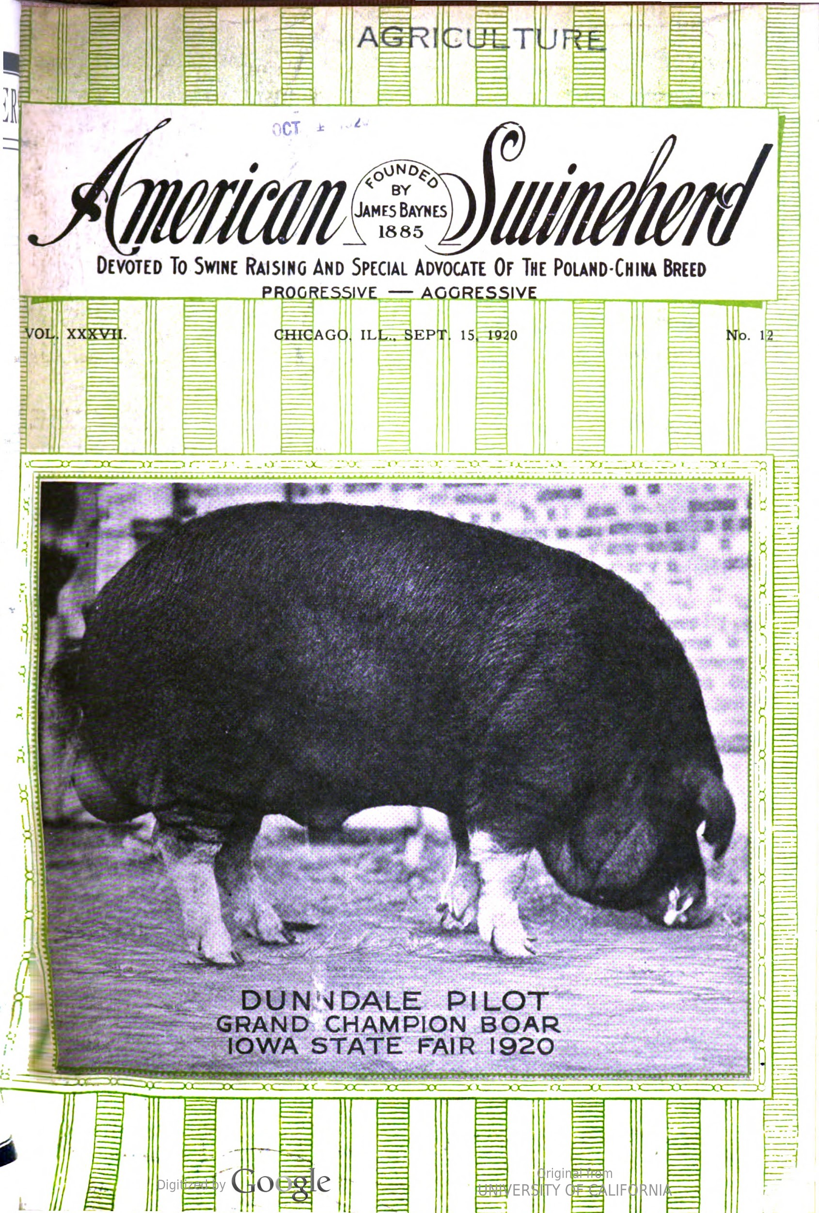

Fig. 3: ‘Dunndale Pilot, Grand Champion Boar, Iowa State Fair 1920,’ Cover, American Swineherd, Vol. 37, no. 12 (September 15, 1920).

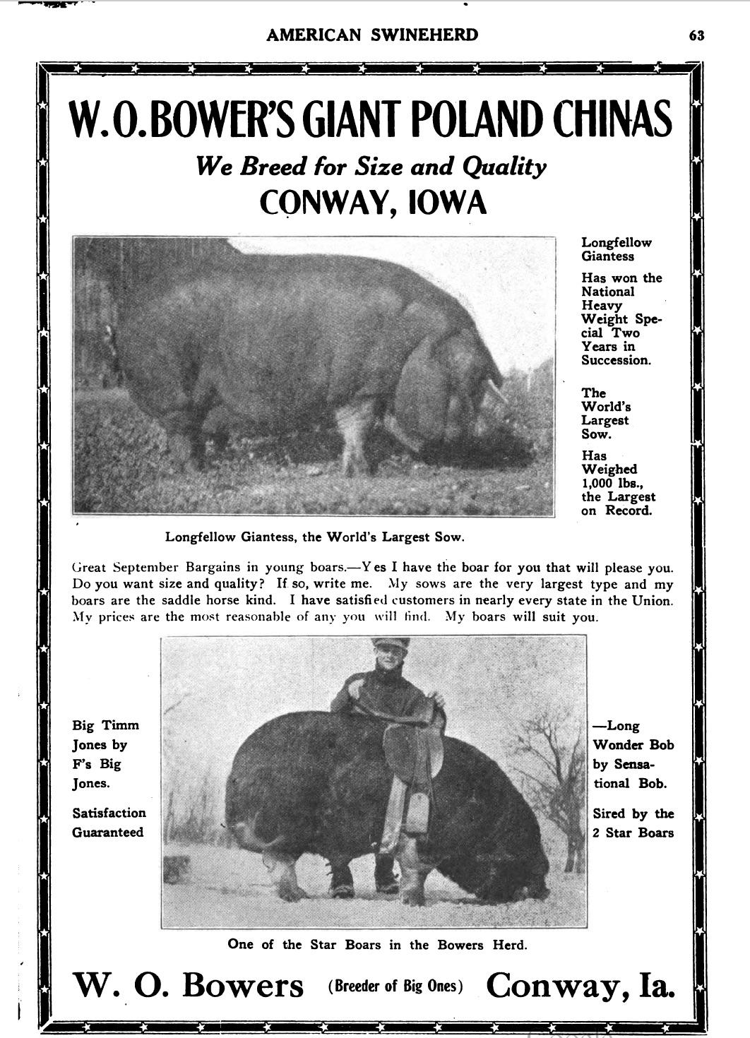

Fig. 4: ‘W.O. Bower’s Giant Poland Chinas,’ advertisement in American Swineherd, Vol. 37, no. 12 (September 15, 1920), p. 63.

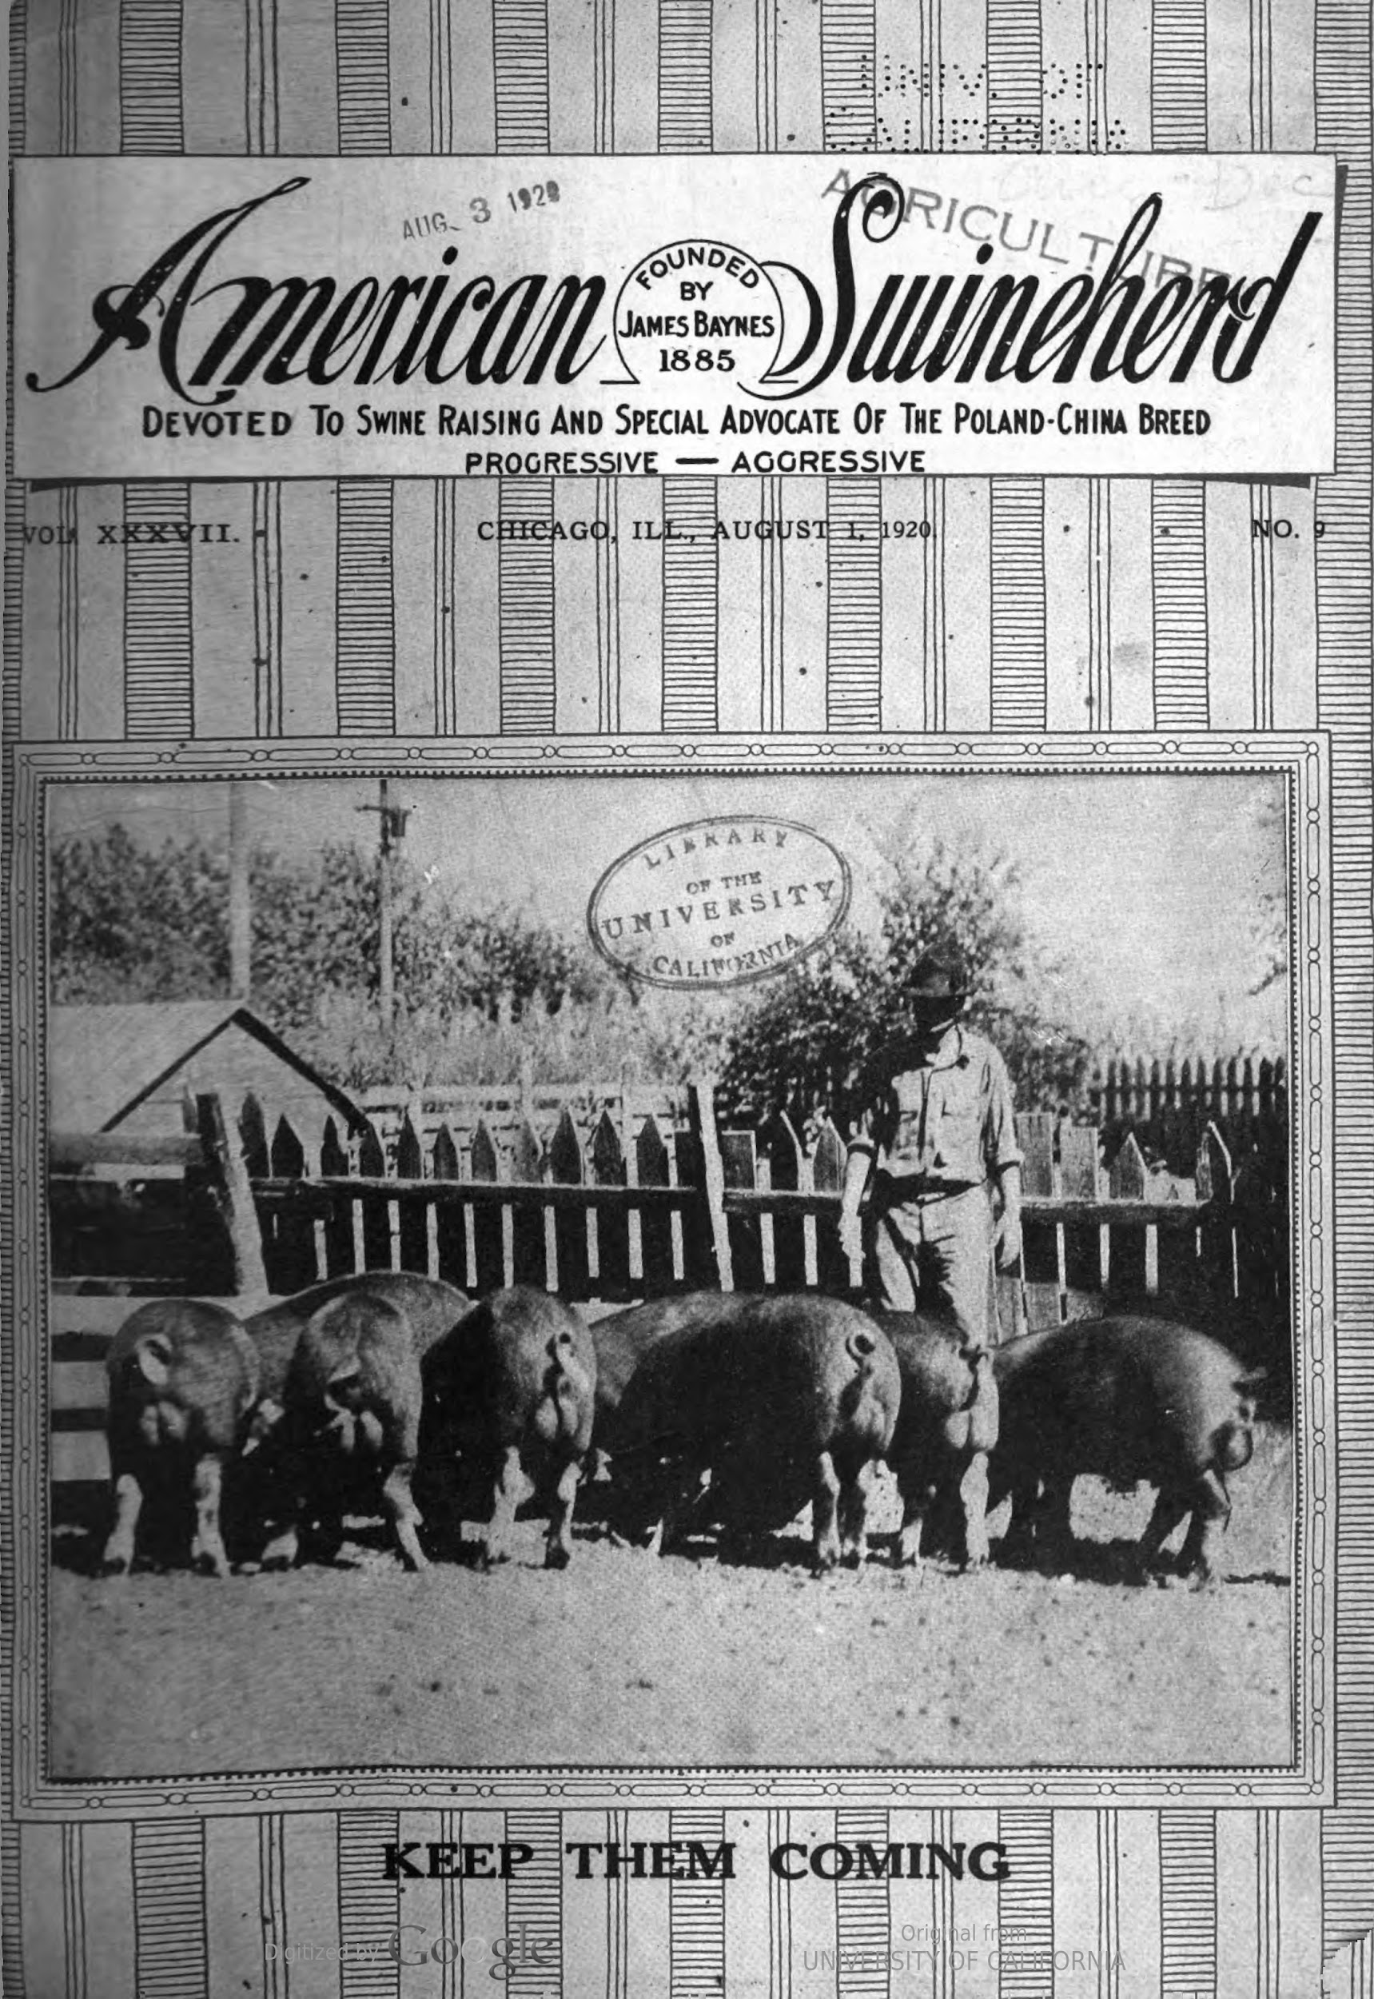

Fig. 5: ‘Keep Them Coming,’ Cover, American Swineherd, Vol. 37, no. 9 (August 1, 1920).

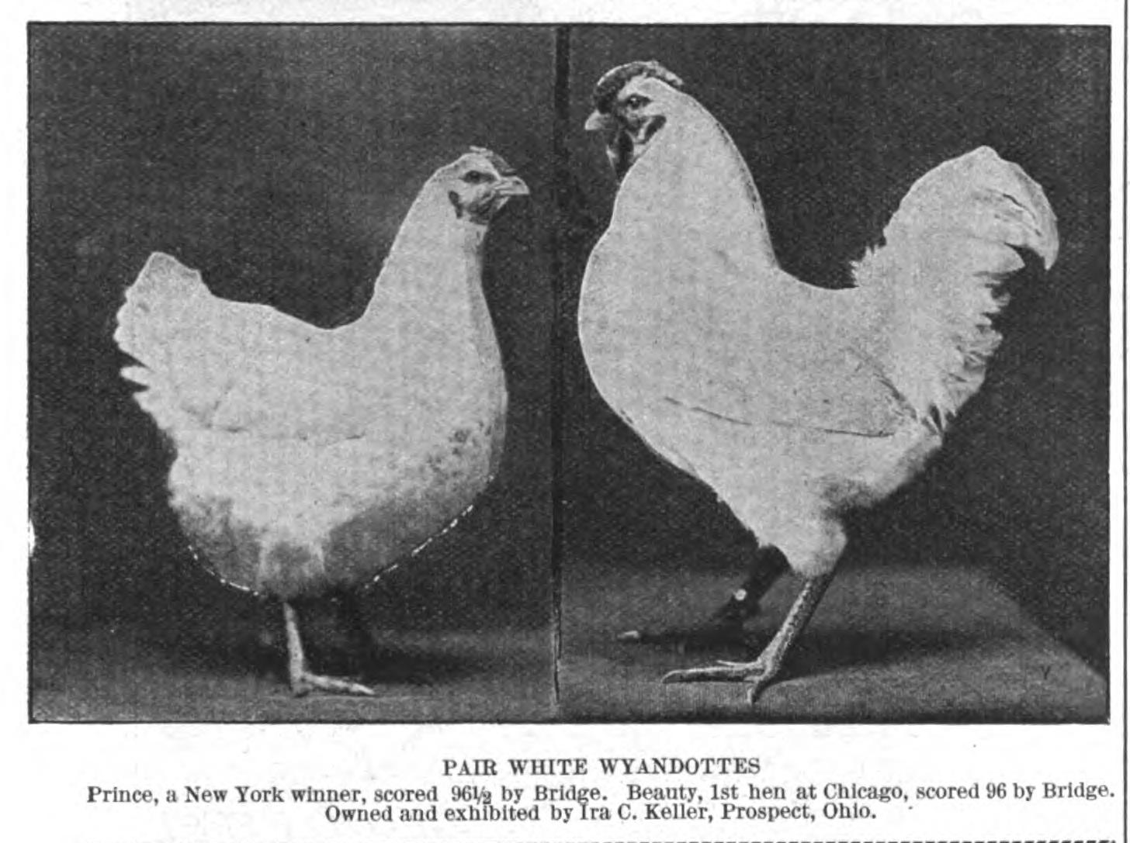

Fig. 6: ‘Pair White Wyandottes,’ from ‘Boston Show: General Description of the Classes,’ American Poultry Journal, Vol. 32, no. 2 (February 1901), p. 128.

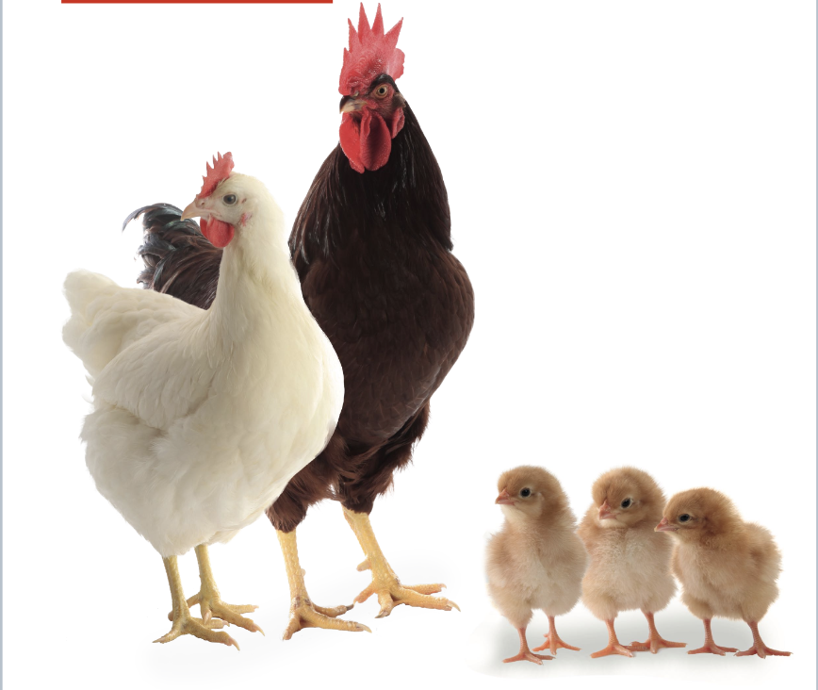

Fig. 7: Cover, ‘Brown Nick: Parent Stock Layer Breeder: New Management Guide,’ H&N International GMbH, https://hn-int.com/downloads/# (accessed 10 March 2022). ©H&N Group 2022; used with permission.



Fig. 8: Advertisement in Breeders Digest (October 2016), p. 9. Certified Pedigreed Swine, cpsswine.com/breeders_digest/2016-october/ (accessed 10 March 2022); used with permission of Certified Pedigreed Swine.

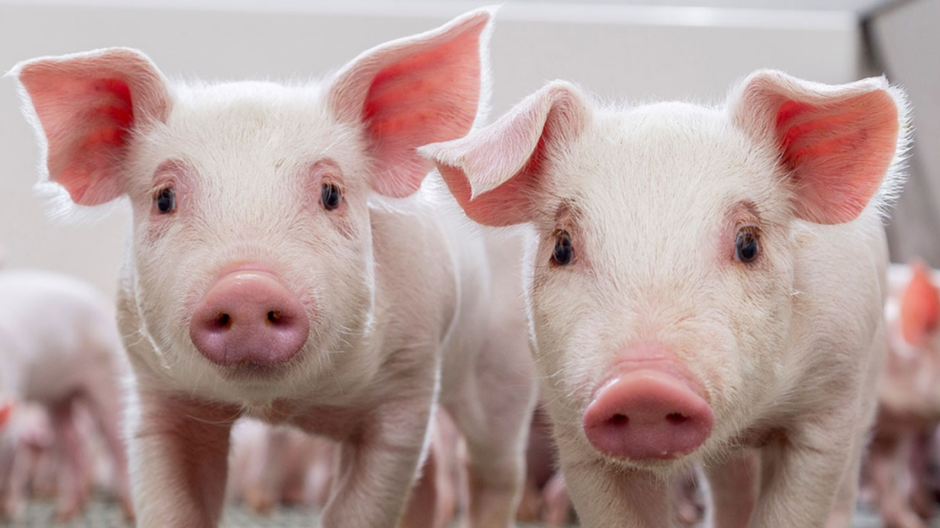

Fig. 9: From ‘Hendrix Genetics: Advanced genetic solutions will improve animal welfare,’ Pig333.com, https://www.pig333.com/company_news/advanced-genetic-solutions-will-improve-animal-welfare_13852/#:~:text=Hendrix%20Genetics%3A%20Advanced%20genetic%20solutions%20will%20improve%20animal%20welfare&text=%E2%80%9CRecombinetics%20has%20a%20proven%20track,for%20routine%20castration%20of%20swine (accessed 19 April 2020). ©Hendrix Genetics Group 2022; used with permission.

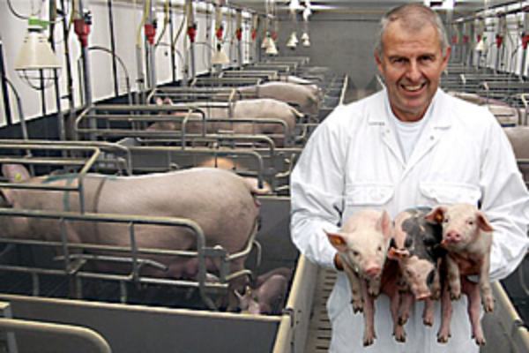

Fig. 10: From ‘Research: Gentec NV,’ Rattlerow, https://rattlerow.co.uk/gentec-nv/ (accessed 19 April 2021). ©Rattlerow Group 2022; used with permission of Rattlerow and the scientist depicted in the image.
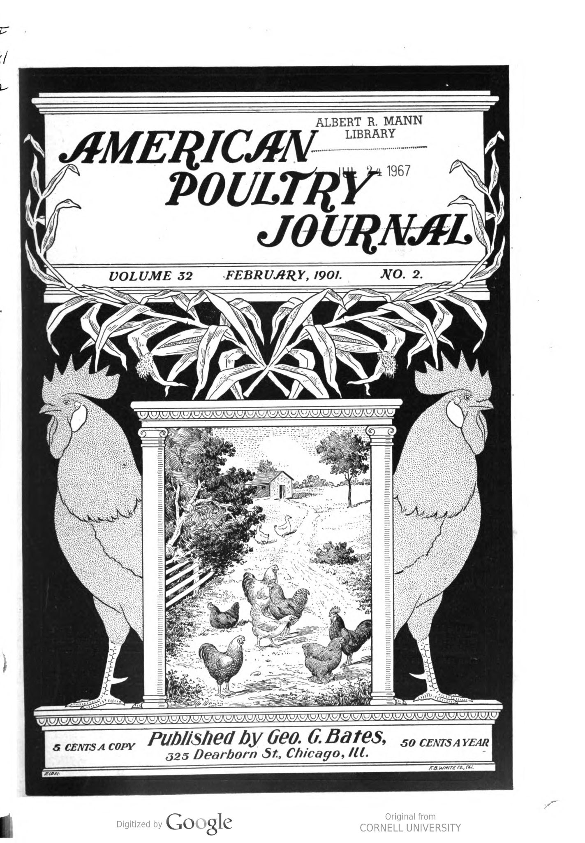

Fig. 11: Cover, American Poultry Journal, Vol. 32, no. 2 (February 1901).

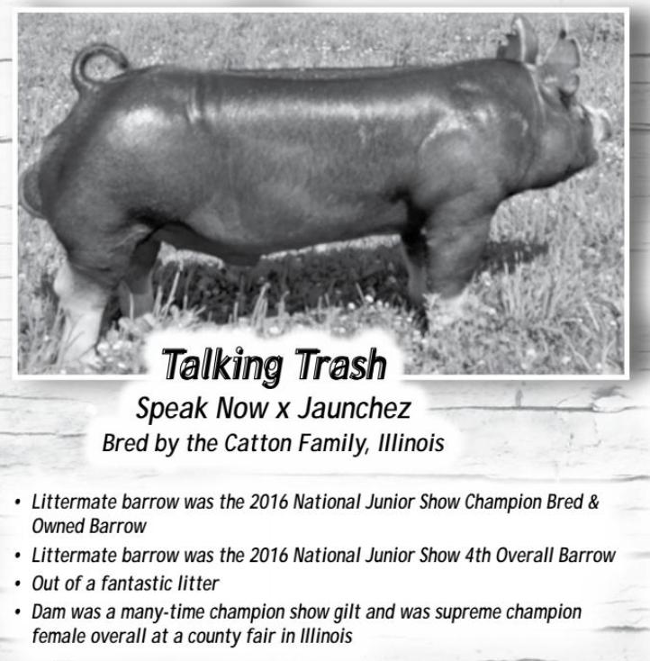

Fig. 12: ‘Talking Trash’, from ‘Brice Conover Berkshires,’ Advertisement, Breeders Digest, October 2016, p. 22. Certified Pedigreed Swine, cpsswine.com/breeders_digest/october-2016/ (accessed 6 May 2021); used with permission of Certified Pedigreed Swine.
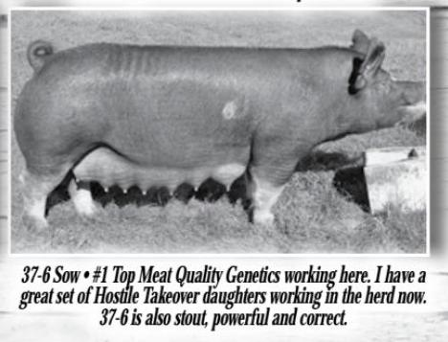

Fig. 13: ‘37-6 Sow’, from ‘Brice Conover Berkshires,’ Advertisement, Breeders Digest, October 2016, p. 21. Certified Pedigreed Swine, cpsswine.com/breeders_digest/october-2016/ (accessed 6 May 2021); used with permission of Certified Pedigreed Swine.



Fig. 14: Banner image, ‘Hypor Libra*,’ Hypor, https://www.hypor.com/en/product/libra/ (accessed 20 April 2021). ©Hypor Group 2021; used with permission.

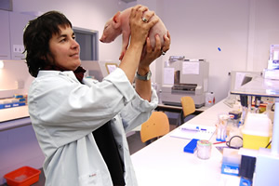

Fig. 15: From ‘Research: Gentec NV,’ Rattlerow, https://rattlerow.co.uk/gentec-nv/ (accessed 21 April 2021). ©Rattlerow Group 2022; used with permission of Rattlerow and the scientist depicted in the image.

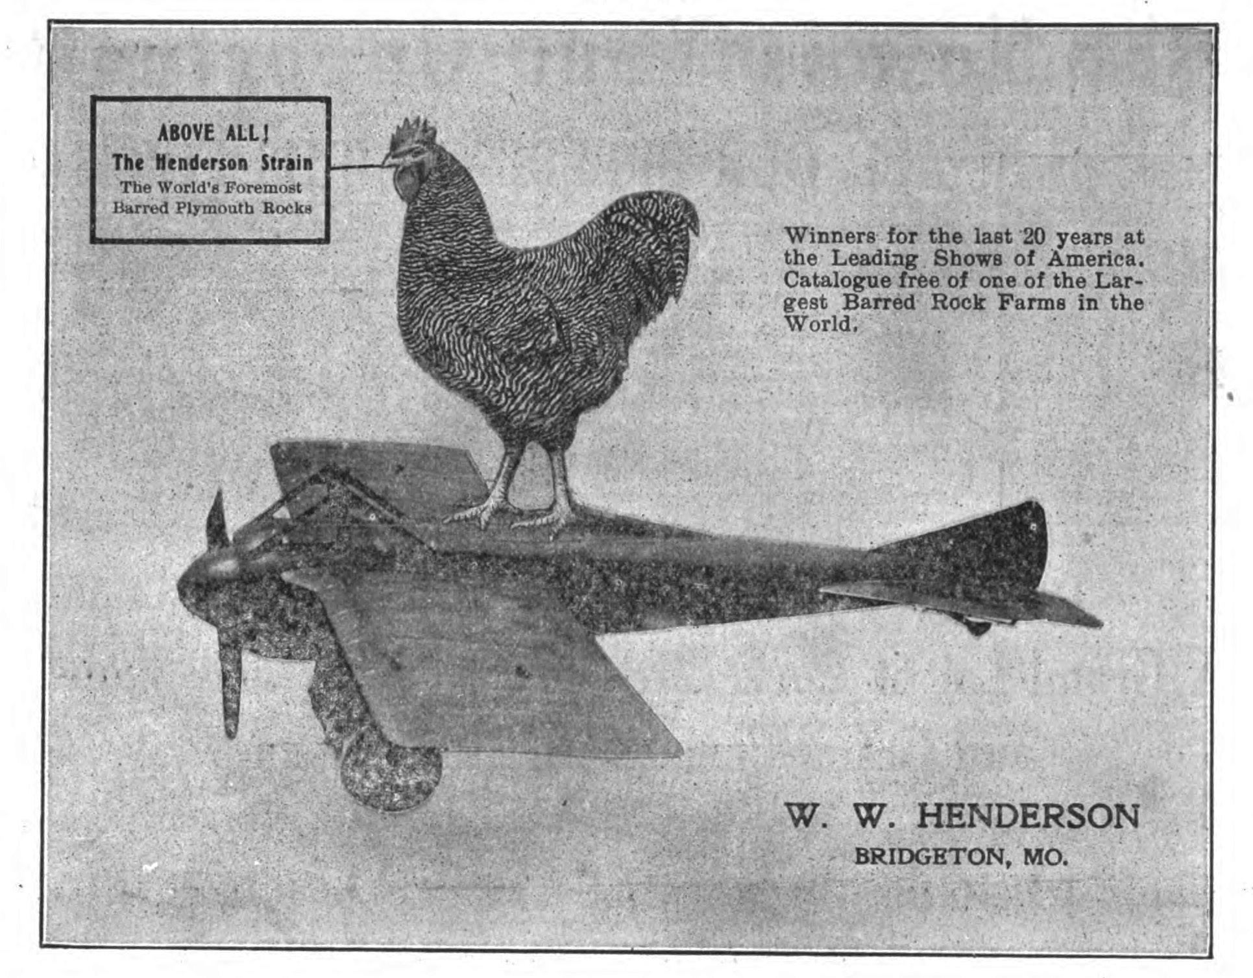
Fig. 16: ‘The Greatest Win Ever Made by a Barred Rock Breeder,’ Advertisement in the National Barred Rock Journal, Vol. 7, no. 6 (November 1915), n.p.

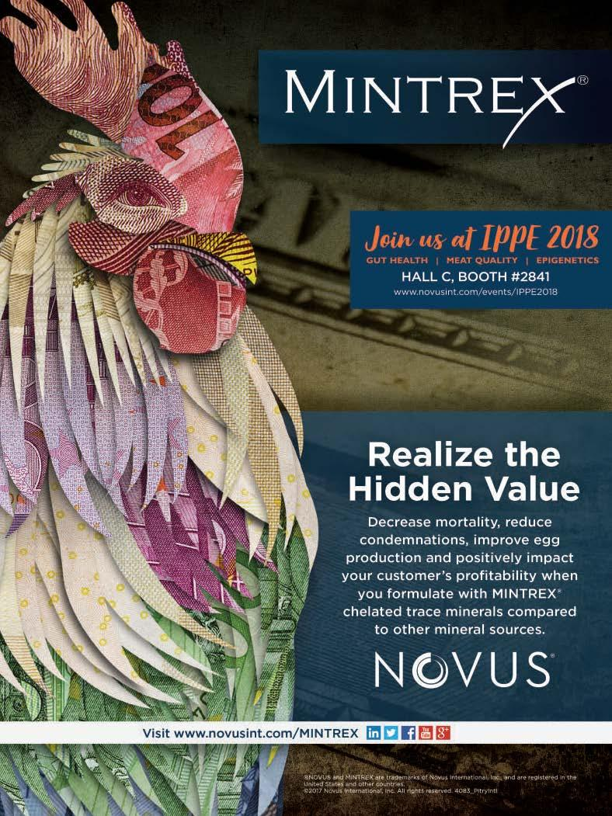

Fig. 17: Mintrex advertisement, Poultry International, January 2018, p. 17, https://www.poultryinternational-digital.com/poultryinternational/201801/MobilePagedReplica.action?pm=2&folio=16#pg18. ©Novus International 2022; used with permission.



Fig. 18: Novus advertisement, Poultry International, June 2020, back cover, https://www.poultryinternational-digital.com/poultryinternational/june_2020/MobilePagedReplica.action?pm=2&folio=C4#pg44. ©Novus International 2022; used with permission.



Fig. 19: From ‘Danbred Breeding Goals and Documented Results,’ Danbred.com, https://danbred.com/en/danbred-breeding-goals-and-documented-results/ (accessed 11 March 2022). ©Danbred Group 2022; used with permission.

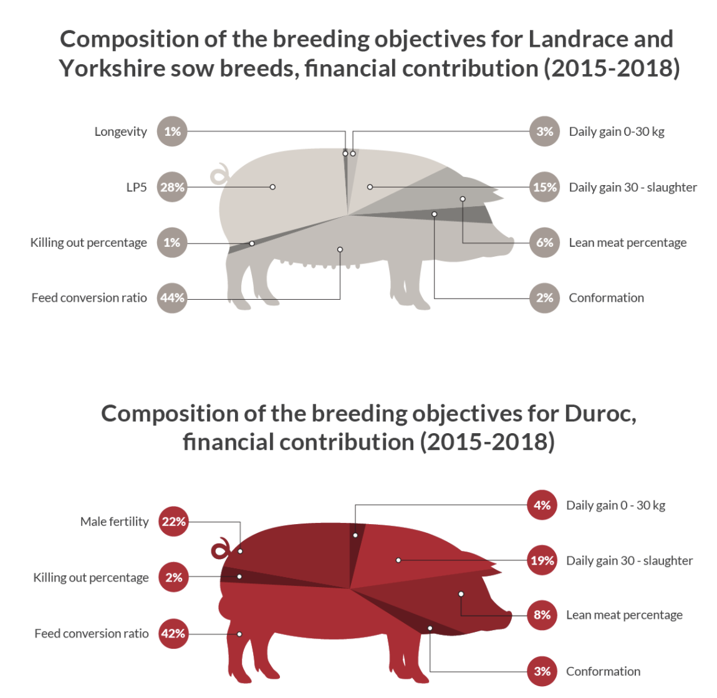

Fig. 20: From ‘New Danbred breeding goals on the way!,’ Danbred.com, https://danbred.com/en/new-danbred-breeding-goals-on-the-way/ (accessed 11 March 2022). ©Danbred Group 2022; used with permission.

